PHASE 2

REQUIREMENT ANALYSIS

PROJECT TITLE: IMPLEMENT CLIENT SCRIPT & UI POLICY (INCIDENT)

Submitted By

Name: K. Yamuna

Department: B.Sc Computer Science

College: Government Arts and Science College for Women, Paramakudi

Platform: ServiceNow

1. INTRODUCTION

- Requirement Analysis is an important phase of software development. It identifies the software, hardware, functional, and technical requirements needed to implement a project.

- This project focuses on improving data integrity in ServiceNow Incident Management using UI Policies and Client Scripts.

2. FUNCTIONAL REQUIREMENTS

The functional requirements of this project are:

1. Create a UI Policy on the Incident table.
2. Apply the UI Policy when Impact is High.
3. Make Assignment Group mandatory.
4. Make Urgency read-only.
5. Automatically set Urgency to High using an onChange Client Script.
6. Prevent saving an Incident when Assigned To is empty for High impact.
7. Prevent State changes through list editing.
8. Allow State updates through the Incident form.
9. Test all configured functionalities.

3. SOFTWARE REQUIREMENTS

- Software| Purpose
- ServiceNow| Project implementation
- Web Browser| Access the platform
- GitHub| Project source and document submission
- Microsoft Word| Project documentation
- Google Drive| Demo video storage

4. HARDWARE REQUIREMENTS

1. Laptop or Desktop Computer
2. Internet Connection
3. Minimum 4 GB RAM
4. Keyboard and Mouse
5. TECHNICAL REQUIREMENTS

The project requires knowledge of:

- ServiceNow Incident Management
- UI Policies
- UI Policy Actions
- Client Scripts
- JavaScript
- Form Validation

6. PROJECT MODULES

Module 1: UI Policy

- Creates conditional field behavior when Incident Impact is High.

Module 2: UI Policy Action

- Makes Assignment Group mandatory and Urgency read-only.

Module 3: onChange Client Script

- Automatically sets Urgency to High when Impact is High.

Module 4: onSubmit Client Script

- Prevents saving the Incident when Assigned To is empty for High impact.

Module 5: onCellEdit Client Script

- Prevents direct State changes through list editing.

Module 6: Testing

- Verifies the expected behavior of all configurations.

7. EXPECTED OUTPUT

The system should:

1. Apply field restrictions when Impact is High.
2. Automatically update Urgency.
3. Display an error when Assigned To is empty.
4. Prevent invalid record submission.
5. Block State changes through list editing.
6. Allow valid form-based updates.

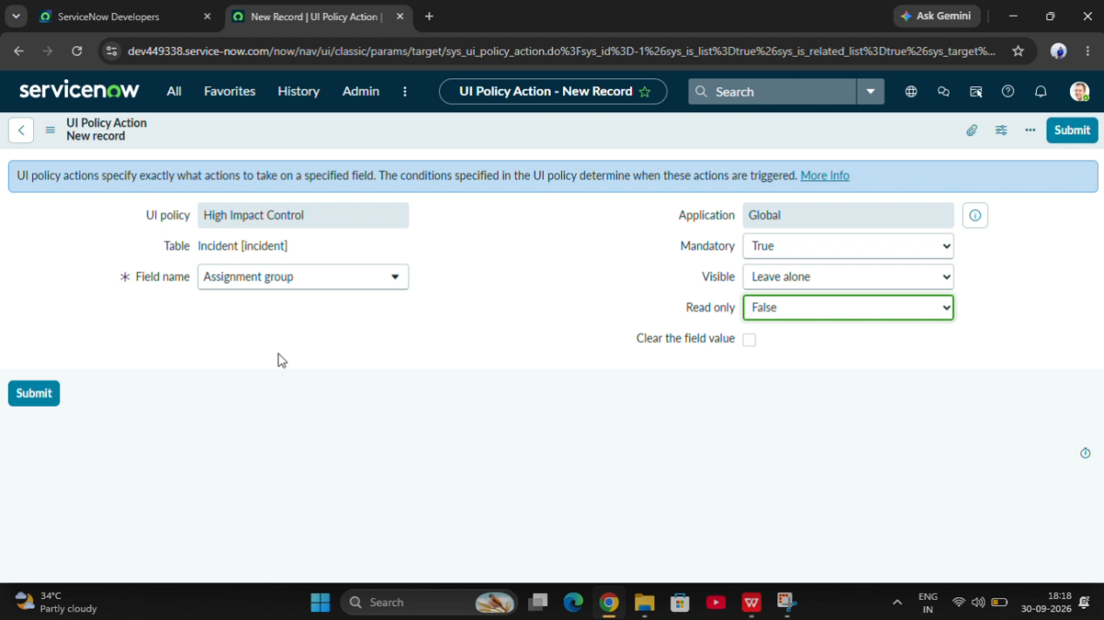

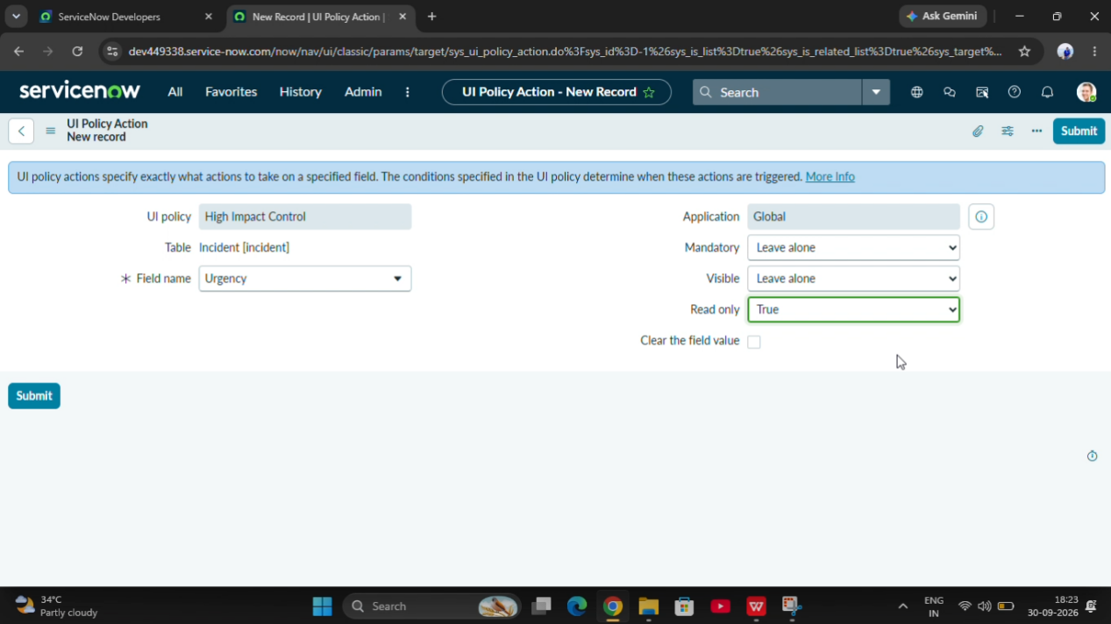

8. CONCLUSION

- Requirement Analysis identifies the necessary software, hardware, technical, and functional requirements for the project.

- These requirements provide a clear foundation for designing and implementing the ServiceNow Client Script and UI Policy solution.

